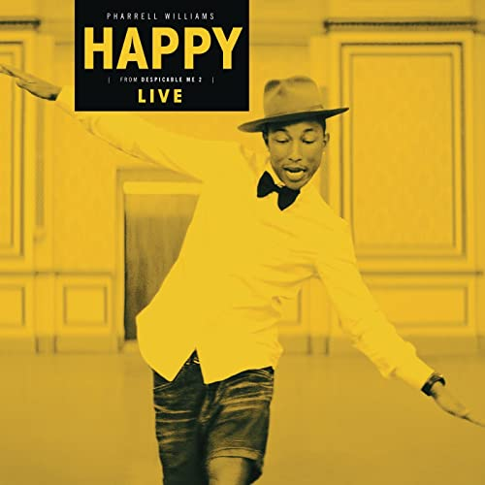
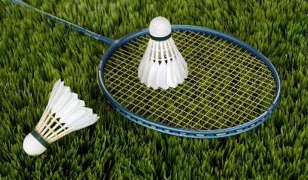
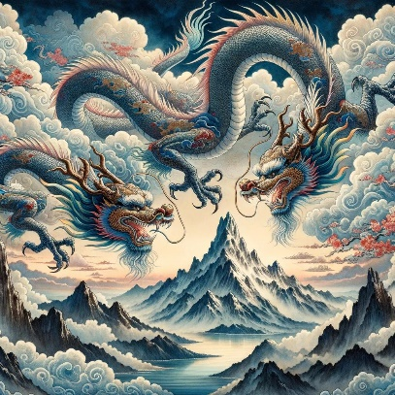
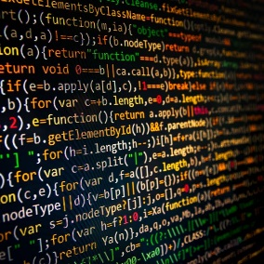
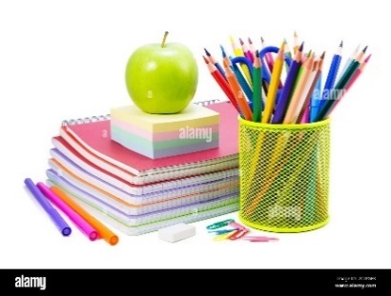
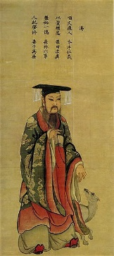
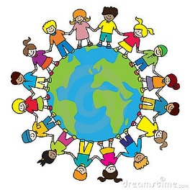
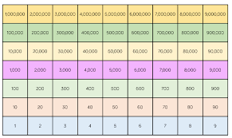
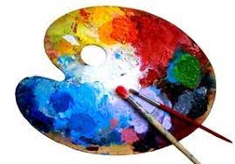
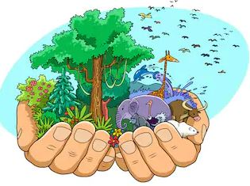
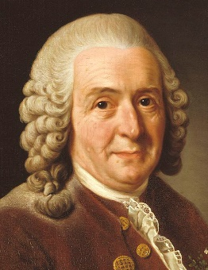
Term 1 - Year 5
Music
Charanga Happy by Pharrell Williams
Learn to sing ‘Happy’ by Pharrell Williams. Develop music notation skills and accompany the performance with tuned and untuned instruments. Continue to develop breathing techniques and ways to improve performance.
DT
Cooking
Improving our skills in cutting, slicing, grating and mixing vegetables to make coleslaw and pate
PE
Badminton (indoors)
Tag Rugby (outdoors)
Developing skills and technique in both sports, building on previous years skills. To show respect, honesty and fair play when competing against an opponent and to be able to apply the rules and tactics learnt, to play in a tournament.

English Studying a range of myths from East Asia, looking at how some of them shaped Chinese culture such as The Great Race, how heroes like Hua Mulan celebrated strength and family loyalty and how the idea of a dragon was considered a good creature in myths.
Poetry and looking at how different poets present their ‘voice’, through Charles Causley, Michael Rosen, Valerie Bloom, Benjamin Zephaniah, Gillian M Ward and Miroslav Holub.
Whole class novel – The White Giraffe

Guided Reading
Developing on from the English focus and expanding to look at a range of myths from different Dynasties alongside Non-Fiction to give context to the topic of the Shang Dynasty
French
A l’école
Continue to broaden vocabulary and accent skills. Focus on school subjects and telling the time
Science
Classifying critters
Look at how animals and plants are divided and grouped. Study the work of Carl Linneas and Edward Jenner. Learn the names of the kingdoms. Investigate how mould and bacteria can help or harm us
RE
Creation
Continue to explore Christianity and the creation of the world
Topic
The Shang Dynasty
Detailed research into the ancient civilisation of The Shang Dynasty. Focus on their legacy, everyday lives, significant figures, language and warfare.
Art
Revision of the colour wheel and complimentary colours.
Sketching of Shang Dynasty artefacts
Develop hatching and shading skills – focus on still life

PSHE
Being Me in My World
Looking at the year ahead and what it is to be a global citizen.
Computing
Coding
Revising our knowledge of coding from Year 4 and developing our skills to create programmes and games using Purple Mash.
Maths
Place Value
Revise our knowledge of place value up to 1,000,000. Comparing and ordering larger numbers. Use the power of 10 to make integers larger and smaller. Use Gattegno and place value charts.

