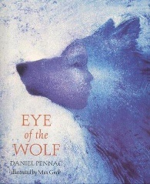
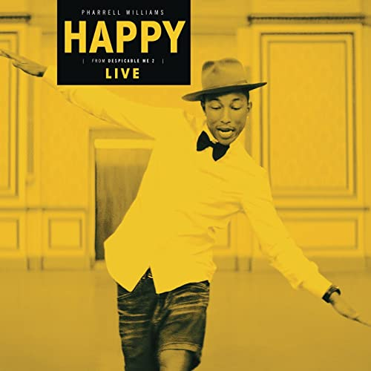
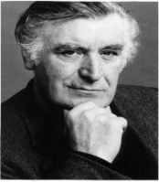
English
Study of the poetry of Ted Hughes
Focus on the seasonal and animal poems of Ted Hughes. Revise poetic language including: metaphor, simile, onomatopoeia, alliteration, personification, rhythm, rhyme and pathetic fallacy. We will create our own poems and publish them.

The Eye of the Wolf by Daniel Pennac. We look at the use of language, devices like flashback and character viewpoint - and how point of view affects our view of events. We look at the impact of narrative viewpoint: who is telling the story, the impact of this on the listeners, and themes within the story (particularly humans as a destructive force). We will complete the unit by retelling a section of the story from the point of view of one of the animal characters.

Year 6
Term 1
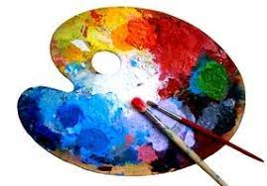

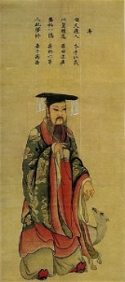
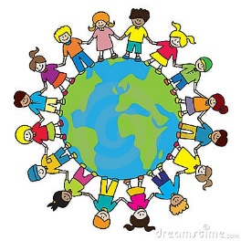
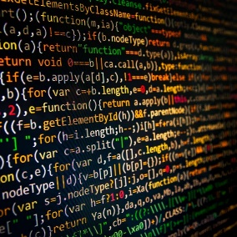
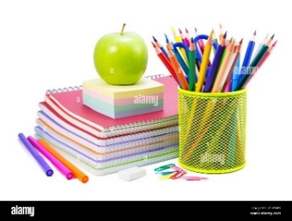
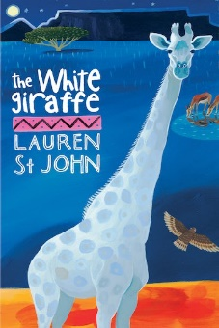
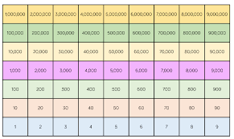
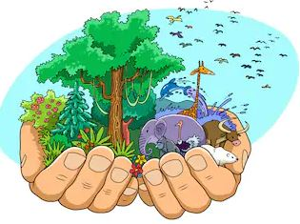
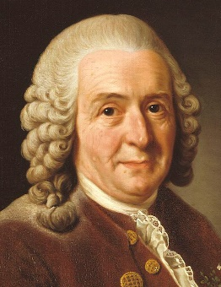
Art
Revision of the colour wheel and complimentary colours.
Sketching of Shang Dynasty artefacts
Develop hatching and shading skills – focus on still life

PE
Badminton (indoors)
Tag Rugby (outdoors)
Developing skills and technique in both sports, building on previous years skills. To show respect, honesty and fair play when competing against an opponent and to be able to apply the rules and tactics learnt, to play in a tournament.

PSHE
Being Me in My World
Looking at the year ahead and what it is to be a global citizen.
DT
Cooking
Improving our skills in cutting, slicing, grating and mixing vegetables to make coleslaw and pate
Music
Charanga Happy by Pharrell Williams
Learn to sing ‘Happy’ by Pharrell Williams. Develop music notation skills and accompany the performance with tuned and untuned instruments. Continue to develop breathing techniques and ways to improve performance.
French
A l’école
Continue to broaden vocabulary and accent skills. Focus on school subjects and telling the time
Science
Classifying critters
Look at how animals and plants are divided and grouped. Study the work of Carl Linneas and Edward Jenner. Learn the names of the kingdoms. Investigate how mould and bacteria can help or harm us.
RE
Creation
Continue to explore Christianity and the creation of the world
Topic
The Shang Dynasty
Detailed research into the ancient civilisation of The Shang Dynasty. Focus on their legacy, everyday lives, significant figures, language and warfare.
Computing
Coding
Revising our knowledge of coding and developing our skills to create programmes and games using Purple Mash.
Guided Reading
Whole class novel
An in-depth look at the complete story of ‘The White Giraffe’ by Lauren St. John. Exploration of new vocabulary, characters, storyline and comprehension.
Maths
Place Value
Revise our knowledge of place value up to 10,000,000. Comparing and ordering larger numbers. Use the power of 10 to make integers larger and smaller. Use Gattegno and place value charts. Calculate using negative numbers and round to the nearest multiple of 10.

